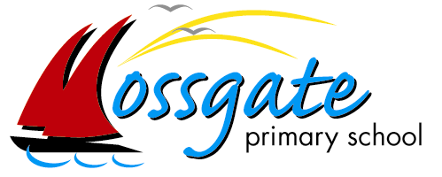
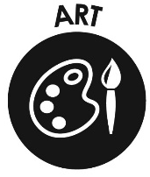
Art - Portrait Overview
‘Working together to achieve success’

During the Summer Term, during Transition Days, children study an artist & produce self-portraits using the artist as inspiration.

EYFS | Vincent Van Gogh | Drawing – use of line  Create closed shapes with continuous lines, and use shapes to represent objects.
Y1 | Chloe Wise | Digital Painting  Choose appropriate tools in a program to create art, and making comparisons with working non-digitally.  Explore the use of line, shape and colour.
Y2 | Paul Klee | Painting/Collage background  Adjust marks & implements to suit a range of textured & coloured backgrounds of different shapes & sizes
Y3 | Andy Warhol | Photography  Manipulate digital images, and reflecting on the impact of changes and whether the required purpose is fulfilled.  Focus: Cropping images, changing colours & applying filters
Y4 | David Hockney | Photography  Manipulate digital images, and reflecting on the impact of changes and whether the required purpose is fulfilled.  Focus: Cloning & combining
Y5 | Pablo Picasso | Drawing – use of shape/colour  Manipulate and experiment with the elements of art: line, form, space, colour and shape.
Y6 | Frida Kahlo | Painting – use of colour & significance of background  Use their knowledge of painting imaginatively to create their own style & talk about it.

